**Name: SALINI K.B**

**Roll No:33**

**Batch:MCA B**

**Date:8-4-2022**

**NETWORKING & SYSTEM ADMINISTRATION LAB**

**Experiment No.: 2**

**Aim**

To familiarize with selecting data from single table 

**Procedure**

1. List all data from table deposite

**select * from deposit;**

**OUTPUT SCREENSHOT**

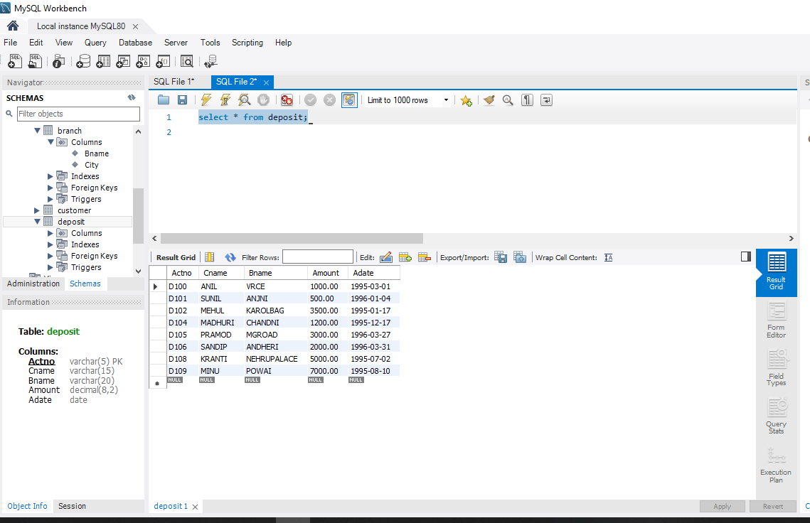

1. List all data from borrow

**select * from borrow;**

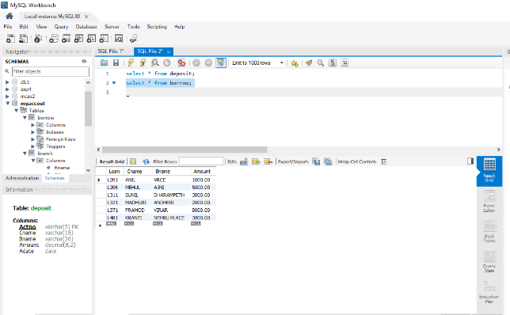

1. List all data from customer

**select * from customer;**

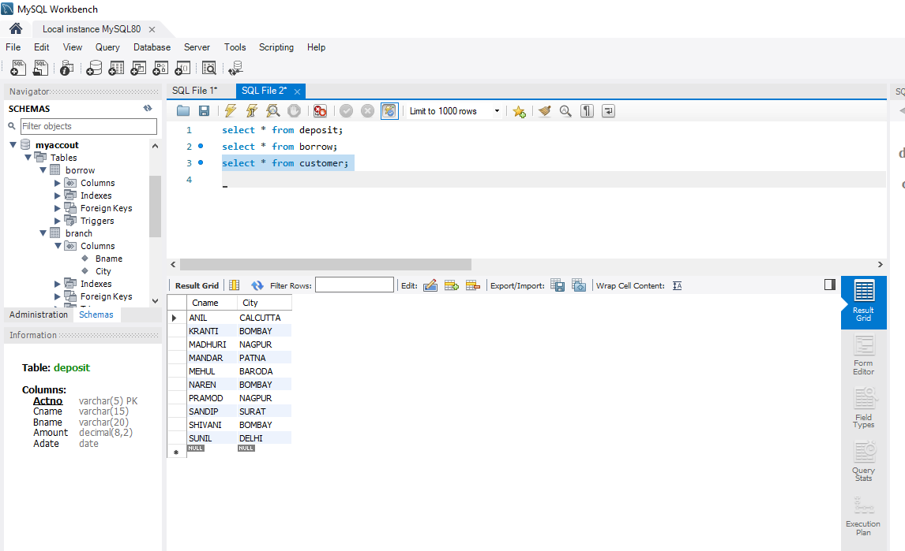

1. List all data from branch

**select * from branch;**

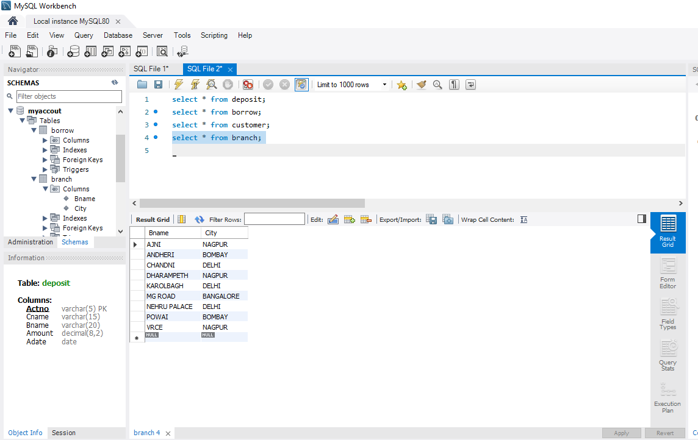

1. Give account no and amount of deposite

**select Actno,Amount from deposit;**

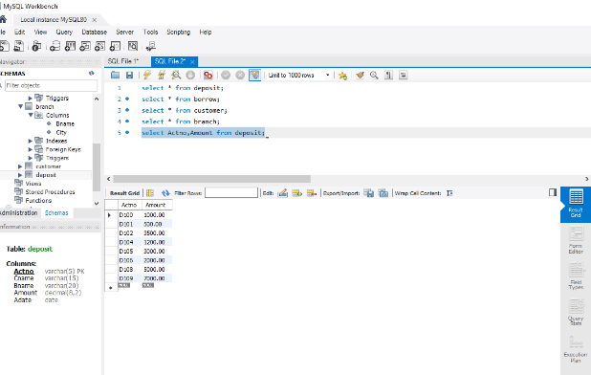

1. Give customer name and account no of depositors

**select Cname,Actno from deposit;**

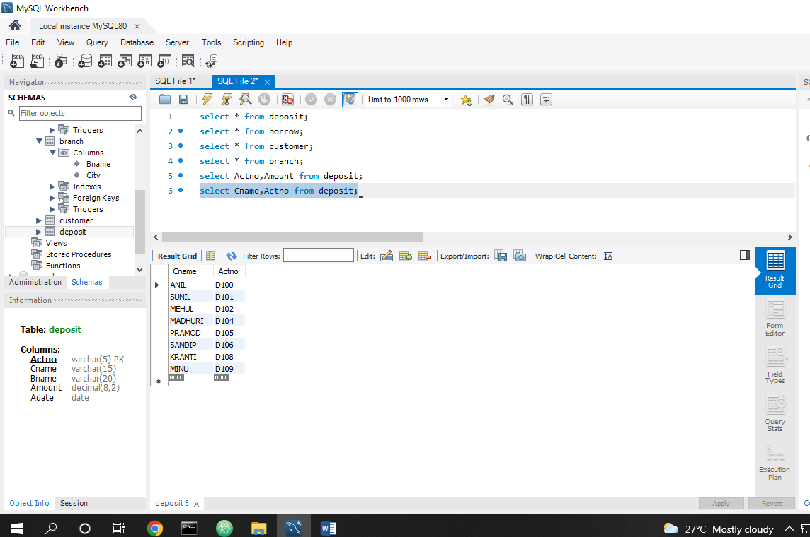

1. Give name of customers

**select Cname from customer;**

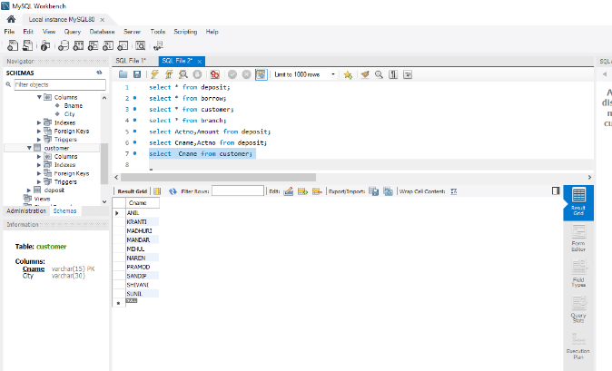

1. Give name of branches

**select Bname from branch;**

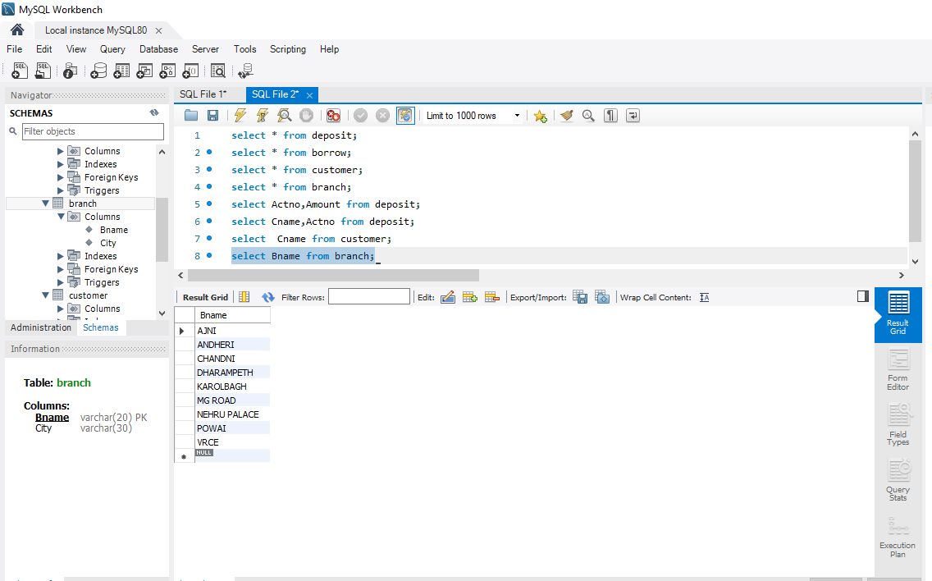

1. Give name of borrows

Select Cname from borrow;

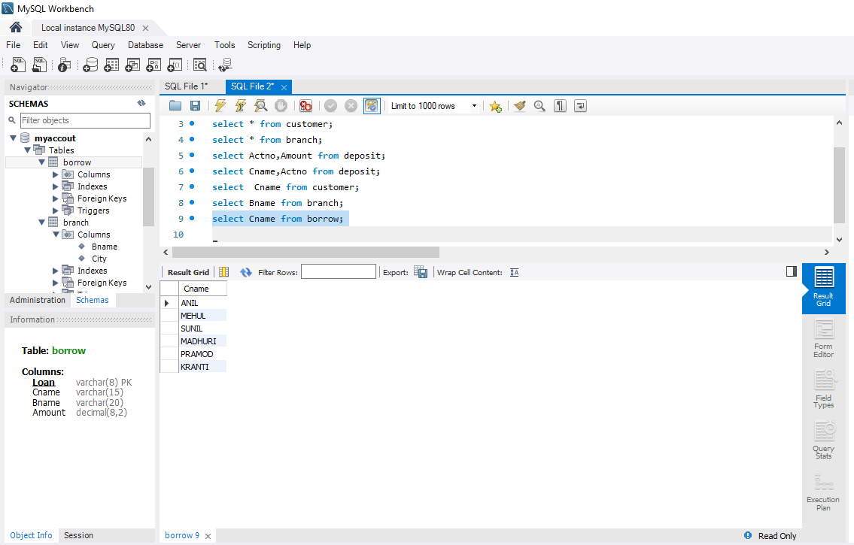

1. Give names of customer living in city Nagpur

**select Cname from customer where City="nagpur";**

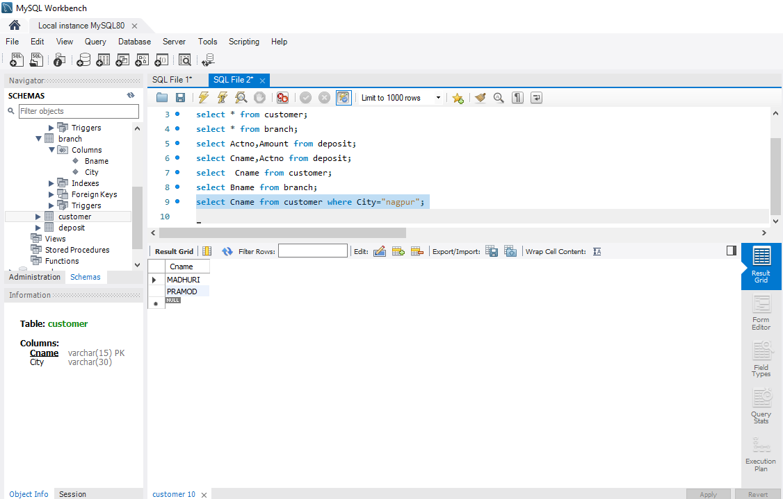

1. Give names of depositors having amount greater than 4000

**select Cname from deposit where amount > 4000;**

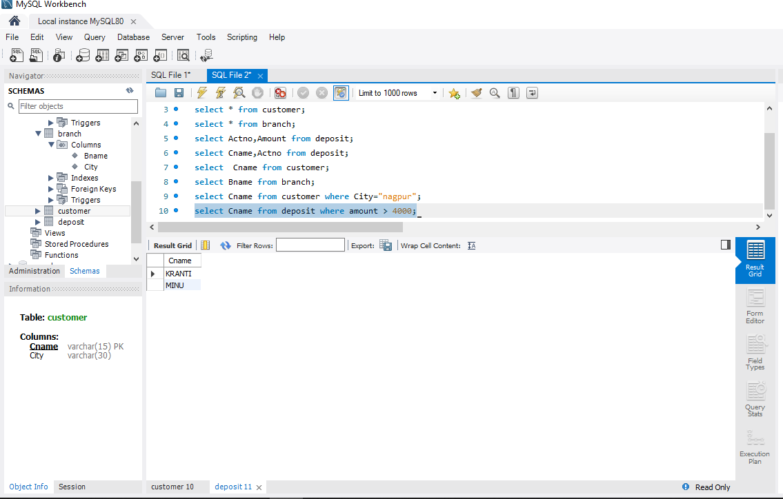

1. Give account date of Anil

**select Adate from deposit where Cname="anil";**

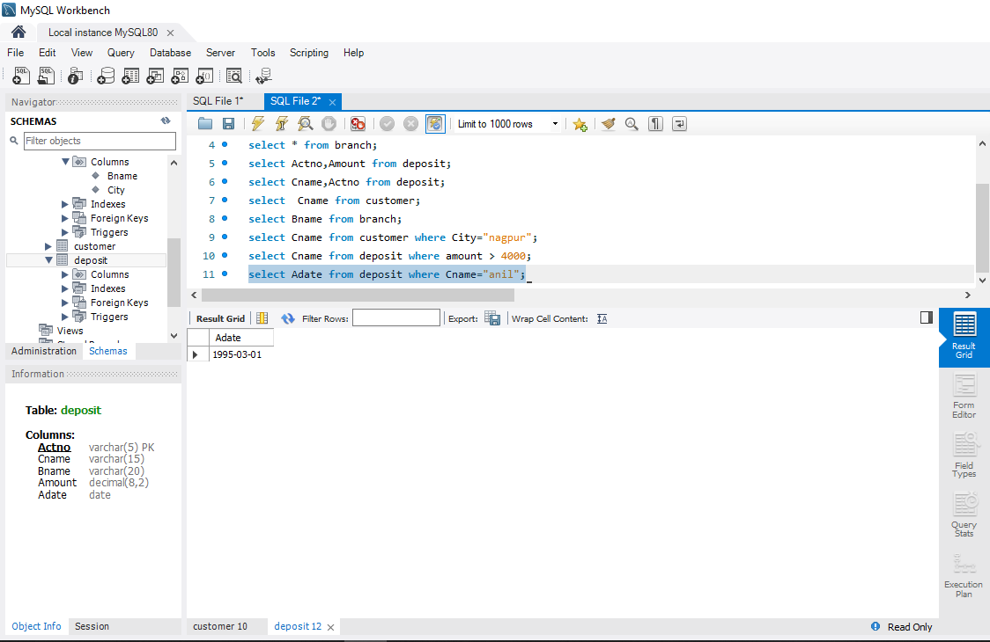

1. Give name of all branches located in Bombay

**select Bname from branch where City="bombay";**

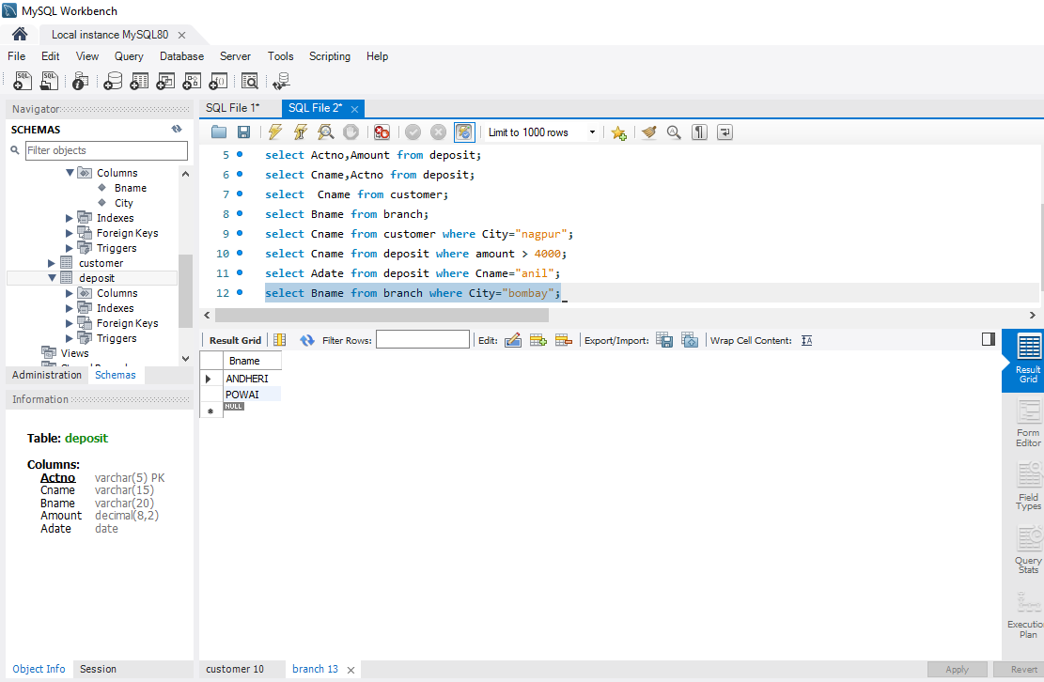

1. Give name of borrower having loan number l206

**select * from borrow;**

**select Cname from borrow where Loan >'L206';**

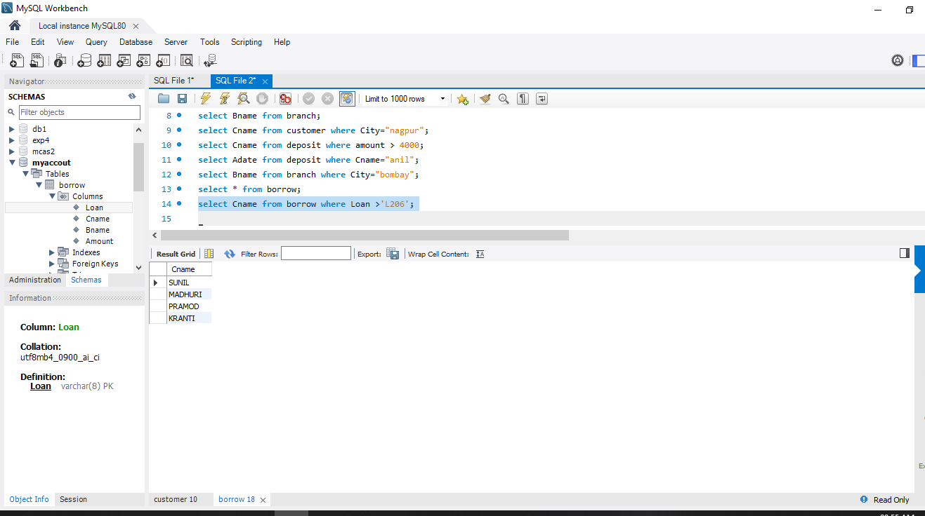

1. Give names of depositors having account at VRCE

**select * from deposit;**

**select Cname from deposit where Bname="VRCE";**

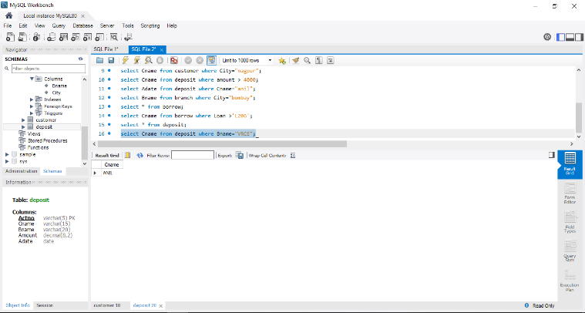

1. Give names of all branched located in city Delhi

**select * from branch;**

**SELECT Bname from branch where city="DELHI";**

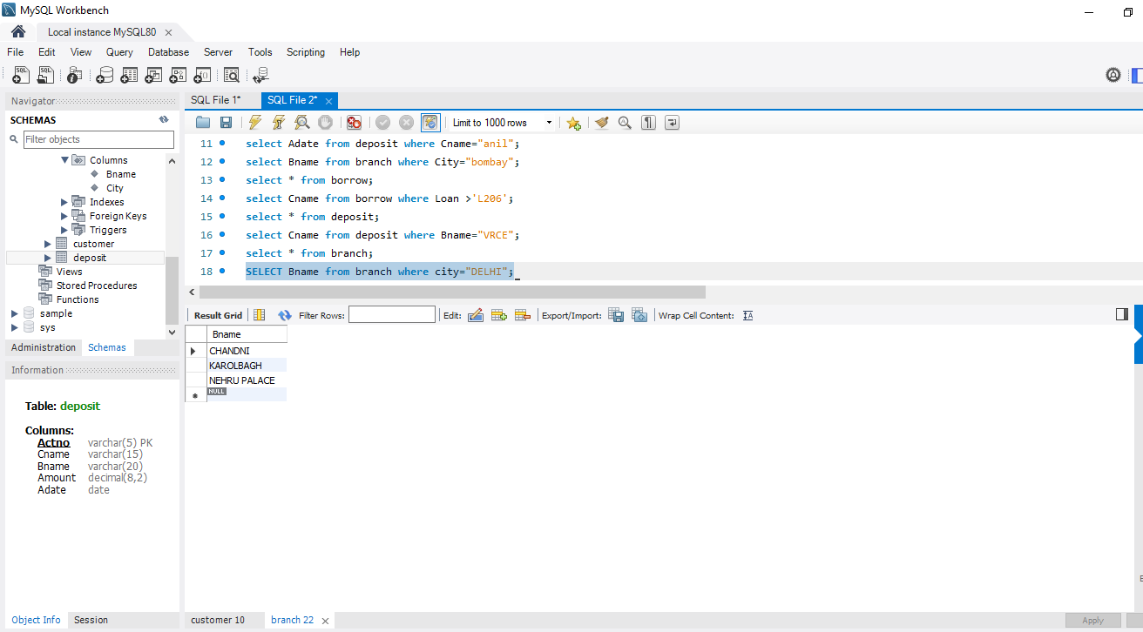

1. Give name of the customers who opened account date ‘1-12-96’

**select * from deposit;**

**SELECT Cname from deposit where Adate='1996-01-04';**

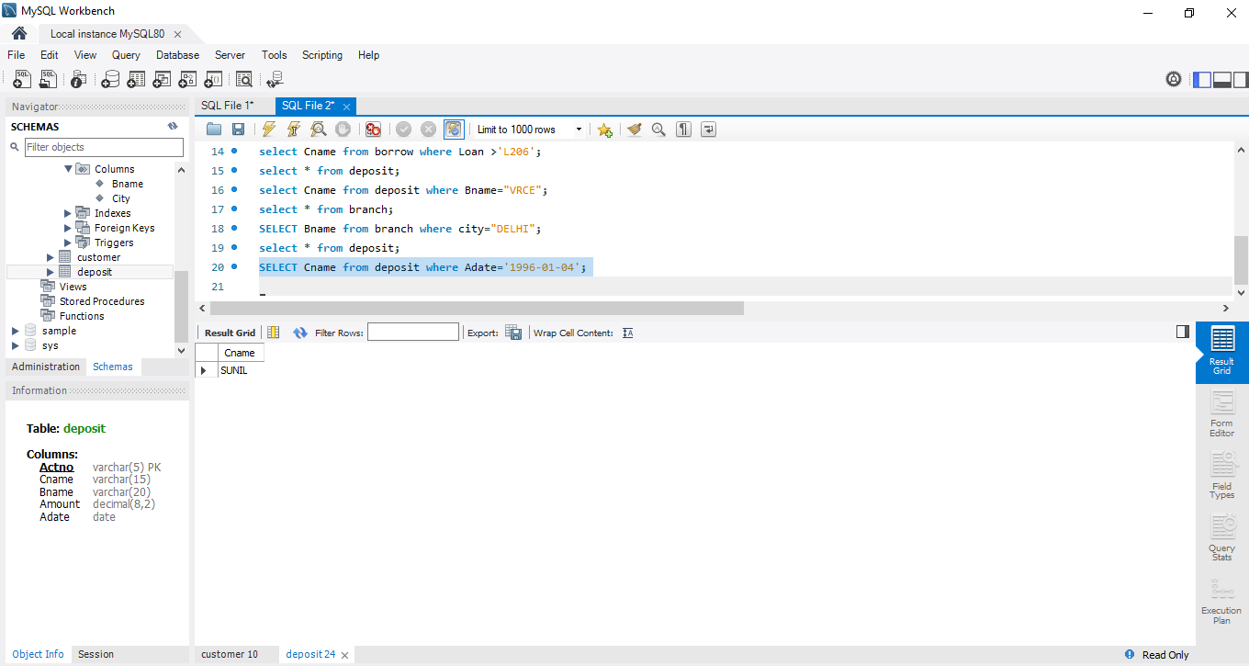

1. Give account no and deposit amount of customers having account opened between dates  ‘1-12-96’ and ‘1-5-96’

**select * from deposit;**

**SELECT Actno,Amount from deposit where Adate Between '1996-01-04' and '1996-03-27';**

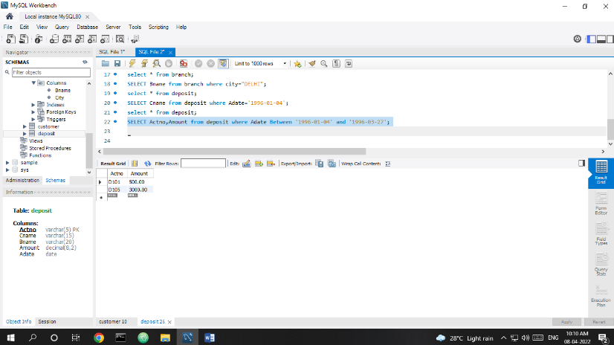

1. Give name of the city where branch KAROLBAGH is located

**SELECT City from branch where Bname="karolbagh";**

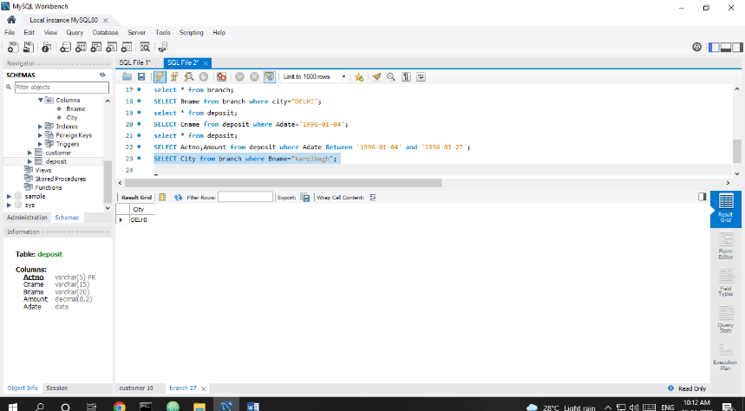

1. Give details of customer ANIL

**SELECT * from customer JOIN borrow on customer.Cname=borrow.Cname join deposit on deposit.Cname=borrow.Cname where customer.Cname="ANIL";**

